Exercise 1: Implementing the Singleton Pattern
Scenario:
You need to ensure that a logging utility class in your application has only one instance throughout the application lifecycle to ensure consistent logging.

Main.java

package com.cognizant;
public class Main {
public static void main(String[] args) {
Logger logger1 = Logger.getInstance();
Logger logger2 = Logger.getInstance();
logger1.log("Application Started");
if(logger1==logger2){
System.out.println("Both are pointing to same objects");
}
else{
System.out.println("Both are pointing to different objects");
}
}
}

Logger.java

package com.cognizant;
public class Logger {
private static Logger instance;
private Logger(){
}
public void log(String message) {
System.out.println(message);
}
public static Logger getInstance(){
if(instance==null){
instance = new Logger();
}
return instance;
}
}
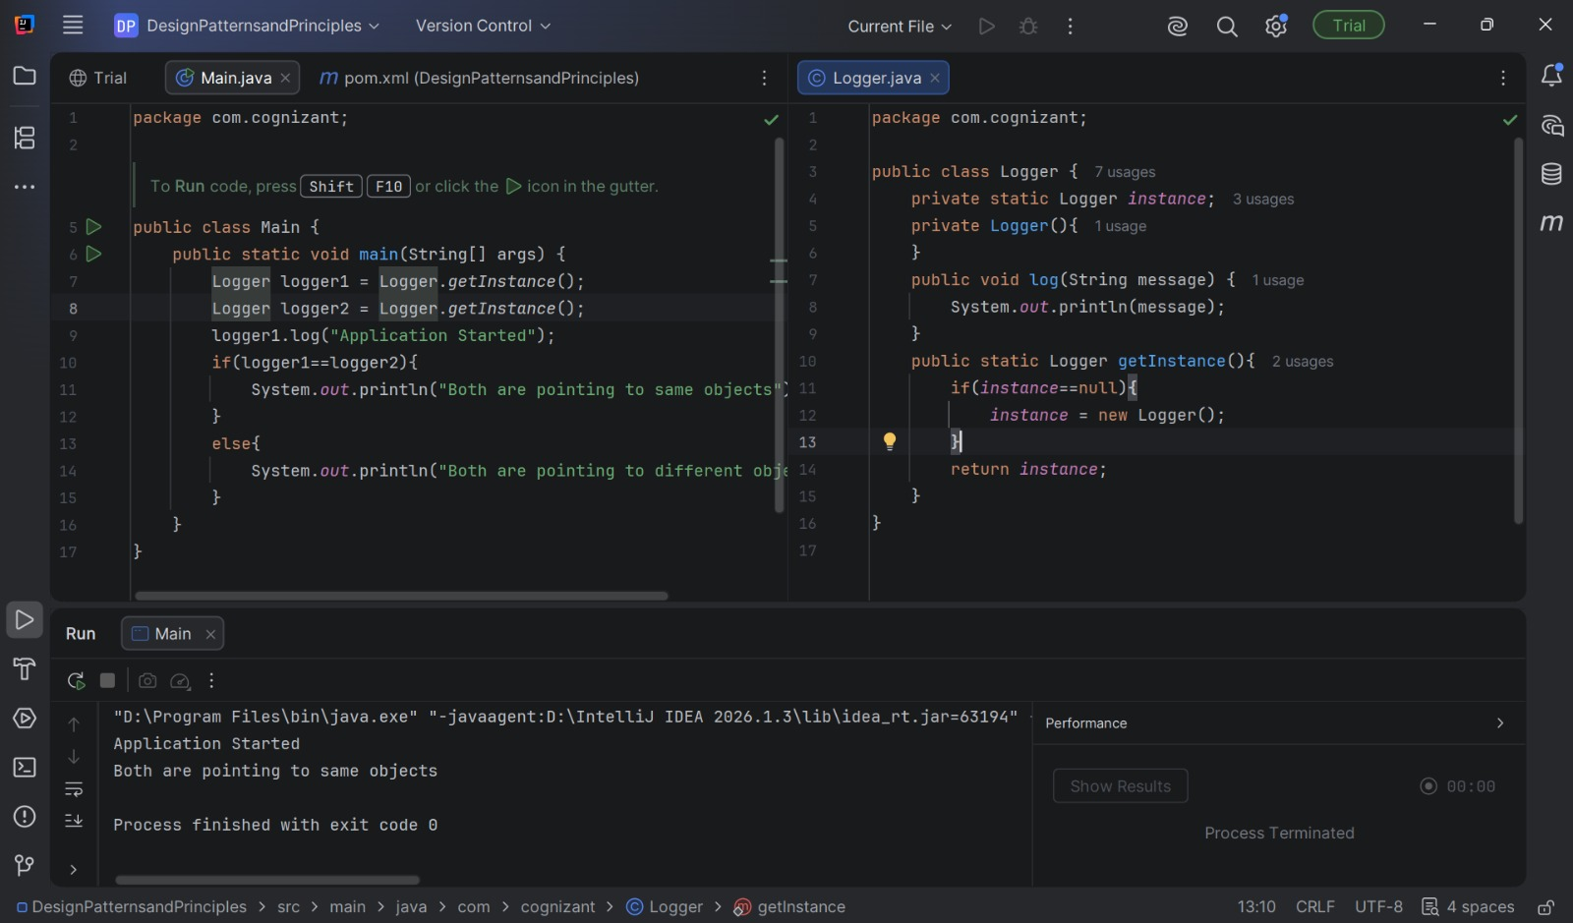
Exercise 2: Implementing the Factory Method Pattern
Scenario:
You are developing a document management system that needs to create different types of documents (e.g., Word, PDF, Excel). Use the Factory Method Pattern to achieve this.

Document.java
package com.cognizant.factory;
public interface Document {
void display();
}

ExcelDocument.java
package com.cognizant.factory;
public class ExcelDocument implements Document{
@Override
public void display(){
System.out.println("Excel Document");
}
}

PdfDocument.java
package com.cognizant.factory;
public class PdfDocument implements Document{
@Override
public void display(){
System.out.println("Pdf Document");
}
}

WordDocument.java
package com.cognizant.factory;
public class WordDocument implements Document{
@Override
public void display() {
System.out.println("Word Document");
}
}

DocumentFactory.java
package com.cognizant.factory;
public abstract class DocumentFactory {
public abstract Document createDocument();
public void displayDocument(){
Document document = createDocument();
document.display();
}
}

WordFactory.java
package com.cognizant.factory;
public class WordFactory extends DocumentFactory{
@Override
public Document createDocument(){
return new WordDocument();
}
}

PdfFactory.java
package com.cognizant.factory;
public class PdfFactory extends DocumentFactory{
@Override
public Document createDocument(){
return new PdfDocument();
}
}

Main.java
package com.cognizant.factory;
public class Main {
public static void main(String[] args){
DocumentFactory pdf = new PdfFactory();
pdf.displayDocument();
DocumentFactory word = new WordFactory();
word.displayDocument();
DocumentFactory excel = new ExcelFactory();
excel.displayDocument();
}
}

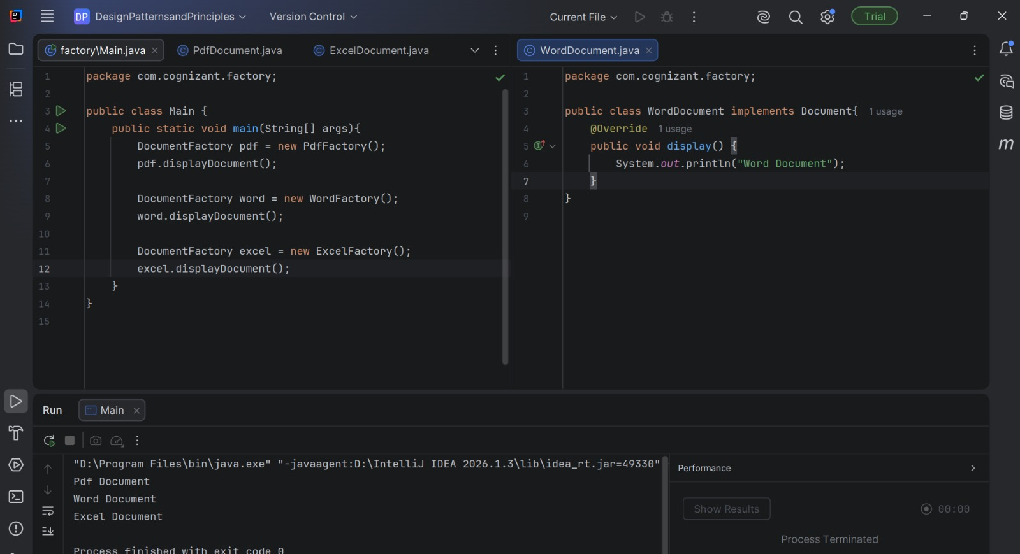

Exercise 3: Implementing the Builder Pattern
Scenario:
You are developing a system to create complex objects such as a Computer with multiple optional parts. Use the Builder Pattern to manage the construction process.

Computer.java

package com.cognizant.BuilderPattern;
public class Computer {
private String cpu;
private String ram;
private String storage;
private String gpu;
private String operatingSystem;
private Computer(Builder builder) {
this.cpu = builder.cpu;
this.ram = builder.ram;
this.storage = builder.storage;
this.gpu = builder.gpu;
this.operatingSystem = builder.operatingSystem;
}
public void display() {
System.out.println("Computer Configuration");
System.out.println("CPU : " + cpu);
System.out.println("RAM : " + ram);
System.out.println("Storage : " + storage);
System.out.println("GPU : " + gpu);
System.out.println("Operating System : " + operatingSystem);
System.out.println();
}
public static class Builder {
private String cpu;
private String ram;
private String storage;
private String gpu;
private String operatingSystem;
public Builder setCPU(String cpu) {
this.cpu = cpu;
return this;
}
public Builder setRAM(String ram) {
this.ram = ram;
return this;
}
public Builder setStorage(String storage) {
this.storage = storage;
return this;
}
public Builder setGPU(String gpu) {
this.gpu = gpu;
return this;
}
public Builder setOperatingSystem(String operatingSystem) {
this.operatingSystem = operatingSystem;
return this;
}
public Computer build() {
return new Computer(this);
}
}
}

Main.java
package com.cognizant.BuilderPattern;
public class Main {
public static void main(String[] args) {
Computer gamingPC = new Computer.Builder()
.setCPU("Intel Core i9")
.setRAM("32 GB")
.setStorage("2 TB SSD")
.setGPU("NVIDIA RTX 4090")
.setOperatingSystem("Windows 11")
.build();
gamingPC.display();
Computer officePC = new Computer.Builder()
.setCPU("Intel Core i5")
.setRAM("16 GB")
.setStorage("512 GB SSD")
.setOperatingSystem("Windows 11")
.build();
officePC.display();
Computer budgetPC = new Computer.Builder()
.setCPU("AMD Ryzen 3")
.setRAM("8 GB")
.build();
budgetPC.display();
}
}

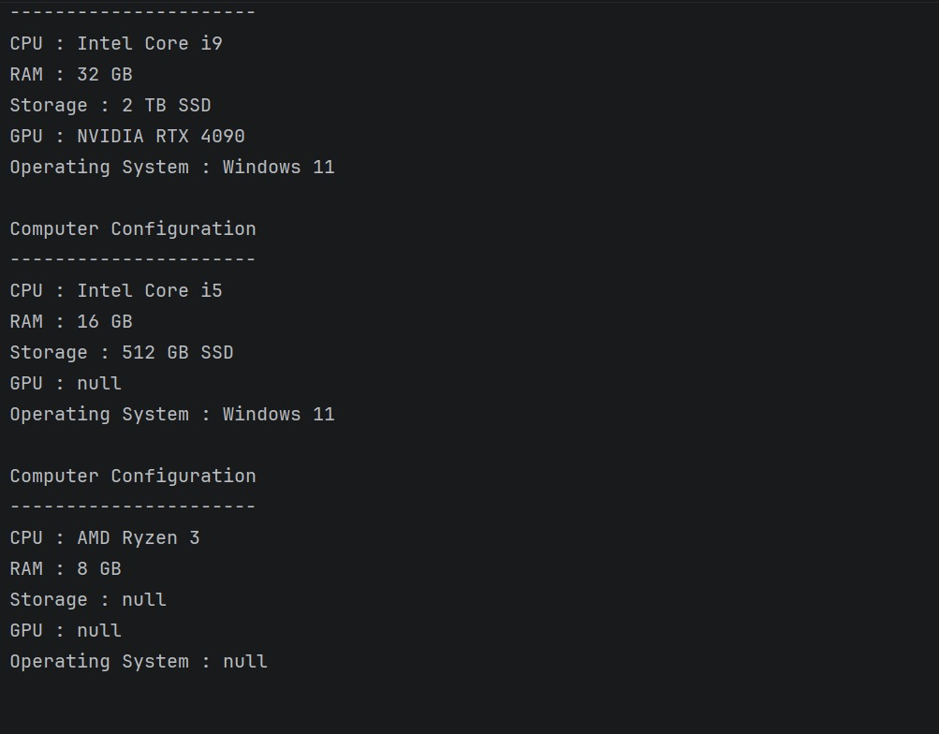

Exercise 4: Implementing the Adapter Pattern
Scenario:
You are developing a payment processing system that needs to integrate with multiple third-party payment gateways with different interfaces. Use the Adapter Pattern to achieve this.

PaymentProcessor.java
package com.cognizant.adapterpattern;
public interface PaymentProcessor {
void processPayment(double amount);
}
PayPalGateway.java
package com.cognizant.adapterpattern;
public class PayPalGateway {
public void sendPayment(double amount) {
System.out.println("PayPal Payment Processed: ₹" + amount);
}
}

StripeGateway.java
package com.cognizant.adapterpattern;
public class StripeGateway {
public void makeTransaction(double amount) {
System.out.println("Stripe Payment Processed: ₹" + amount);
}
}

PayPalAdapter.java
package com.cognizant.adapterpattern;
public class PayPalAdapter implements PaymentProcessor {
private PayPalGateway paypalGateway;
public PayPalAdapter(PayPalGateway paypalGateway) {
this.paypalGateway = paypalGateway;
}
@Override
public void processPayment(double amount) {
paypalGateway.sendPayment(amount);
}
}

StripeAdapter.java
package com.cognizant.adapterpattern;
public class StripeAdapter implements PaymentProcessor {
private StripeGateway stripeGateway;

public StripeAdapter(StripeGateway stripeGateway) {
this.stripeGateway = stripeGateway;
}
@Override
public void processPayment(double amount) {
stripeGateway.makeTransaction(amount);
}
}

Main.java
package com.cognizant.adapterpattern;
public class Main {
public static void main(String[] args) {
PaymentProcessor paypal =
new PayPalAdapter(new PayPalGateway());
PaymentProcessor stripe =
new StripeAdapter(new StripeGateway());
paypal.processPayment(5000);
stripe.processPayment(7500);
}
}
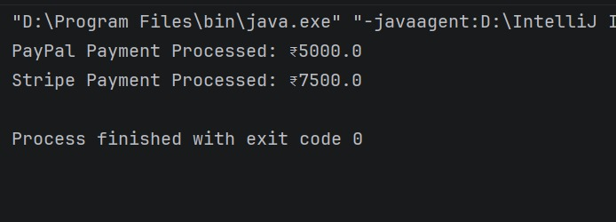

Exercise 5: Implementing the Decorator Pattern
Scenario:
You are developing a notification system where notifications can be sent via multiple channels (e.g., Email, SMS). Use the Decorator Pattern to add functionalities dynamically.
Notifier.java
package decoratorpatternexample;

public interface Notifier {
void send(String message);
}

EmailNotifier.java
package decoratorpatternexample;
public class EmailNotifier implements Notifier {
@Override
public void send(String message) {
System.out.println("Sending Email: " + message);
}
}

NotifierDecorator.java
package decoratorpatternexample;
public abstract class NotifierDecorator implements Notifier {
protected Notifier notifier;
public NotifierDecorator(Notifier notifier) {
this.notifier = notifier;
}
@Override
public void send(String message) {
notifier.send(message);
}
}

SMSNotifierDecorator.java
package decoratorpatternexample;
public class SMSNotifierDecorator extends NotifierDecorator {
public SMSNotifierDecorator(Notifier notifier) {
super(notifier);
}
@Override
public void send(String message) {
super.send(message);
System.out.println("Sending SMS: " + message);
}
}

SlackNotifierDecorator.java
package decoratorpatternexample;
public class SlackNotifierDecorator extends NotifierDecorator {
public SlackNotifierDecorator(Notifier notifier) {
super(notifier);
}
@Override
public void send(String message) {
super.send(message);
System.out.println("Sending Slack Notification: " + message);
}
}

Main.java
package decoratorpatternexample;

public class Main {
public static void main(String[] args) {
System.out.println("Email Notification");
Notifier email = new EmailNotifier();
email.send("Welcome!");
System.out.println();
System.out.println("Email + SMS Notification");
Notifier emailSMS =
new SMSNotifierDecorator(new EmailNotifier());
emailSMS.send("Your OTP is 123456");
System.out.println();
System.out.println("Email + SMS + Slack Notification");
Notifier allChannels =
new SlackNotifierDecorator(
new SMSNotifierDecorator(
new EmailNotifier()));
allChannels.send("Server is Down!");
}
}

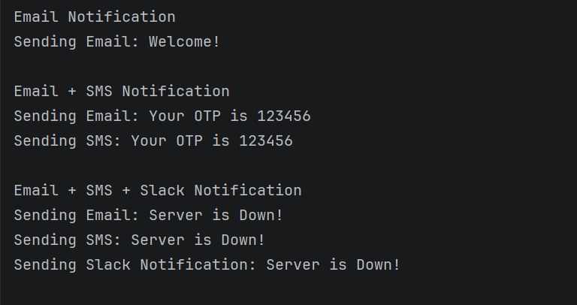

Exercise 6: Implementing the Proxy Pattern
Scenario:
You are developing an image viewer application that loads images from a remote server. Use the Proxy Pattern to add lazy initialization and caching.
Image.java
package proxypatternexample;
public interface Image {
void display();
}

RealImage.java
package proxypatternexample;
public class RealImage implements Image {
private String fileName;
public RealImage(String fileName) {
this.fileName = fileName;
loadFromServer();
}
private void loadFromServer() {
System.out.println("Loading image from remote server: " + fileName);
}
@Override
public void display() {
System.out.println("Displaying image: " + fileName);
}
}

ProxyImage.java
package proxypatternexample;
public class ProxyImage implements Image {
private String fileName;
private RealImage realImage;
public ProxyImage(String fileName) {
this.fileName = fileName;
}
@Override
public void display() {
if (realImage == null) {
realImage = new RealImage(fileName);
}
realImage.display();
}
}

Main.java
package proxypatternexample;
public class Main {
public static void main(String[] args) {
Image image = new ProxyImage("Nature.jpg");
System.out.println("First Display:");
image.display();
System.out.println();
System.out.println("Second Display:");
image.display();
}
}

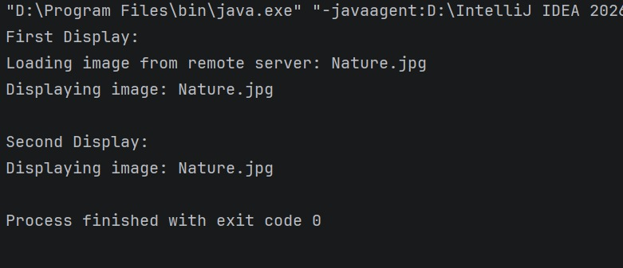

Exercise 7: Implementing the Observer Pattern
Scenario:
You are developing a stock market monitoring application where multiple clients need to be notified whenever stock prices change. Use the Observer Pattern to achieve this.

Stock.java
package observerpatternexample;
public interface Stock {
void registerObserver(Observer observer);
void deregisterObserver(Observer observer);
void notifyObservers();
}

Observer.java
package observerpatternexample;
public interface Observer {
void update(String stockName, double price);
}

StockMarket.java
package observerpatternexample;

import java.util.ArrayList;
import java.util.List;

public class StockMarket implements Stock {
private List<Observer> observers = new ArrayList<>();
private String stockName;
private double stockPrice;
@Override
public void registerObserver(Observer observer) {
observers.add(observer);
}
@Override
public void deregisterObserver(Observer observer) {
observers.remove(observer);
}
@Override
public void notifyObservers() {
for (Observer observer : observers) {
observer.update(stockName, stockPrice);
}
}
public void setStock(String stockName, double stockPrice) {
this.stockName = stockName;
this.stockPrice = stockPrice;
System.out.println("\nStock Updated");
System.out.println("Stock : " + stockName);
System.out.println("Price : ₹" + stockPrice);
notifyObservers();
}
}

MobileApp.java
package observerpatternexample;

public class MobileApp implements Observer {
private String user;
public MobileApp(String user) {
this.user = user;
}
@Override
public void update(String stockName, double price) {
System.out.println("Mobile App (" + user + ") Notification:");
System.out.println(stockName + " price updated to ₹" + price);
}
}

Main.java
package observerpatternexample;

public class Main {
public static void main(String[] args) {
StockMarket stockMarket = new StockMarket();
Observer mobile = new MobileApp("Alice");
Observer web = new WebApp("Bob");
stockMarket.registerObserver(mobile);
stockMarket.registerObserver(web);
stockMarket.setStock("TCS", 3500.50);
stockMarket.deregisterObserver(web);
stockMarket.setStock("Infosys", 1525.75);
}
}
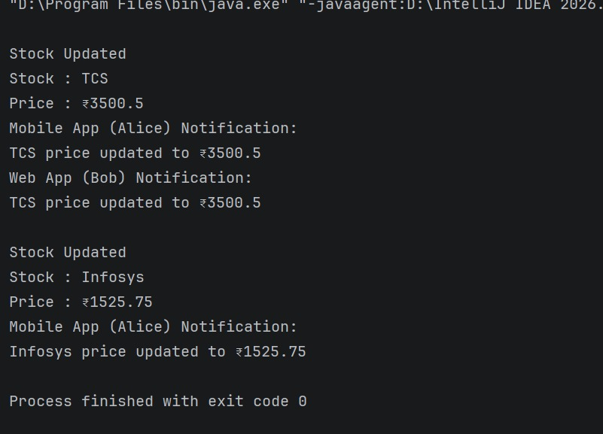
Exercise 8: Implementing the Strategy Pattern
Scenario:
You are developing a payment system where different payment methods (e.g., Credit Card, PayPal) can be selected at runtime. Use the Strategy Pattern to achieve this.

PaymentStrategy.java
package strategypatternexample;
public interface PaymentStrategy {
void pay(double amount);
}

CreditCardPayment.java
package strategypatternexample;
public class CreditCardPayment implements PaymentStrategy {
@Override
public void pay(double amount) {
System.out.println("Paid ₹" + amount + " using Credit Card.");
}
}

PayPalPayment.java
package strategypatternexample;
public class PayPalPayment implements PaymentStrategy {
@Override
public void pay(double amount) {
System.out.println("Paid ₹" + amount + " using PayPal.");
}
}

PaymentContext.java
package strategypatternexample;
public class PaymentContext {
private PaymentStrategy paymentStrategy;
public PaymentContext(PaymentStrategy paymentStrategy) {
this.paymentStrategy = paymentStrategy;
}
public void setPaymentStrategy(PaymentStrategy paymentStrategy) {
this.paymentStrategy = paymentStrategy;
}
public void makePayment(double amount) {
paymentStrategy.pay(amount);
}
}

Main.java
package strategypatternexample;
public class Main {
public static void main(String[] args) {
PaymentContext paymentContext =
new PaymentContext(new CreditCardPayment());
paymentContext.makePayment(5000);
paymentContext.setPaymentStrategy(new PayPalPayment());
paymentContext.makePayment(2500);
}
}

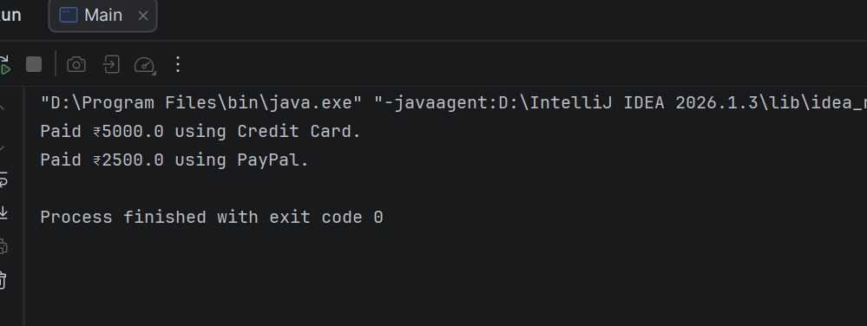
Exercise 9: Implementing the Command Pattern
Scenario: You are developing a home automation system where commands can be issued to turn devices on or off. Use the Command Pattern to achieve this.

Command.java
package commandpatternexample;
public interface Command {
void execute();
}

Light.java
package commandpatternexample;
public class Light {
public void turnOn() {
System.out.println("Light is ON");
}
public void turnOff() {
System.out.println("Light is OFF");
}
}

LightOnCommand.java
package commandpatternexample;
public class LightOnCommand implements Command {
private Light light;
public LightOnCommand(Light light) {
this.light = light;
}
@Override
public void execute() {
light.turnOn();
}
}
LightOffCommand.java
package commandpatternexample;
public class LightOffCommand implements Command {
private Light light;
public LightOffCommand(Light light) {
this.light = light;
}
@Override
public void execute() {
light.turnOff();
}
}
RemoteControl.java
package commandpatternexample;
public class RemoteControl {
private Command command;
public void setCommand(Command command) {
this.command = command;
}
public void pressButton() {
command.execute();
}
}

Main.java
package commandpatternexample;
public class Main {
public static void main(String[] args) {
Light light = new Light();

Command lightOn = new LightOnCommand(light);
Command lightOff = new LightOffCommand(light);
RemoteControl remote = new RemoteControl();
remote.setCommand(lightOn);
remote.pressButton();
remote.setCommand(lightOff);
remote.pressButton();
}
}
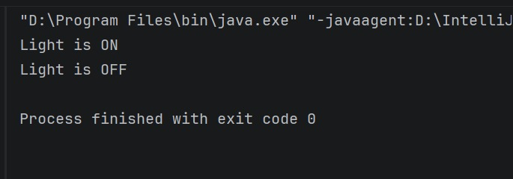

Exercise 10: Implementing the MVC Pattern
Scenario:
You are developing a simple web application for managing student records using the MVC pattern.

Student.java
package mvcpatternexample;
public class Student {
private String name;
private int id;
private String grade;
public Student(String name, int id, String grade) {
this.name = name;
this.id = id;
this.grade = grade;
}
public String getName() {
return name;
}
public void setName(String name) {
this.name = name;
}
public int getId() {
return id;
}
public void setId(int id) {
this.id = id;
}
public String getGrade() {
return grade;
}
public void setGrade(String grade) {
this.grade = grade;
}
}

StudentView.java
package mvcpatternexample;
public class StudentView {
public void displayStudentDetails(String name, int id, String grade) {
System.out.println("Student Details");
System.out.println("Name : " + name);
System.out.println("ID : " + id);
System.out.println("Grade : " + grade);
}
}

StudentController.java
package mvcpatternexample;
public class Main {
public static void main(String[] args) {
Student student = new Student("Lakshmi", 101, "A");
StudentView view = new StudentView();
StudentController controller =
new StudentController(student, view);
controller.updateView();
System.out.println();
controller.setStudentName("Maheswari");
controller.setStudentGrade("A+");
controller.updateView();
}
}

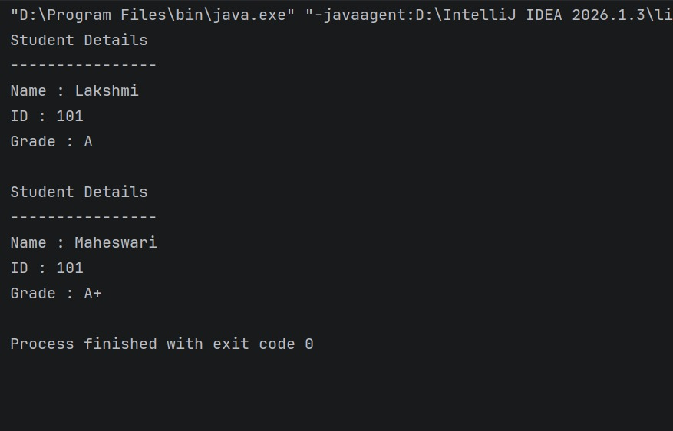
Exercise 11: Implementing Dependency Injection
Scenario:
You are developing a customer management application where the service class depends on a repository class. Use Dependency Injection to manage these dependencies.

CustomerRepository.java
package dependencyinjectionexample;
public interface CustomerRepository {
String findCustomerById(int id);
}

CustomerRepositoryImpl.java
package dependencyinjectionexample;

public class CustomerRepositoryImpl implements CustomerRepository {
@Override
public String findCustomerById(int id) {
return "Customer ID: " + id + ", Name: Lakshmi";
}
}

CustomerService.java
package dependencyinjectionexample;
public class CustomerService {
private CustomerRepository customerRepository;
public CustomerService(CustomerRepository customerRepository) {
this.customerRepository = customerRepository;
}
public void getCustomer(int id) {
String customer = customerRepository.findCustomerById(id);
System.out.println(customer);
}
}

Main.java
package dependencyinjectionexample;
public class Main {
public static void main(String[] args) {
CustomerRepository repository =
new CustomerRepositoryImpl();
CustomerService service =
new CustomerService(repository);
service.getCustomer(101);
}
}
